```Asia-China -Bronze-W Han-Ding

Property from Various Owners

A cast bronze covered ding

**Western Han**  
The compressed globular vessel with a band of scrolling taotie decoration on the body and two bands on the domed lid containing a central double-mask and ring handle surrounded by three raised finials of recumbent horses, the main body flanked by flared rectangular handles with a raised horizontal bead border in the middle with an incised inscription directly below the band, raised on three squat cabriole legs, the surface with raised mineral deposits and dirt throughout.   
*8in (20.3cm) width over handles  
6 1/2in (16.5cm) high*

Estimate:

US$ 40,000 - 60,000  
£25,000 - 38,000  
€30,000 - 45,000

#### Contacts

Angela Lee

San Francisco,

United States

Tel: +1 415 503 3358

Fax: +1 415 503 3300

[angela.lee@bonhams.com](mailto:angela.lee@bonhams.com?subject=Re:Lot 5198, Auction 20901, A cast bronze covered ding Western Han, 12 Mar 2013)

Auction Administration - Chinese Works of Art

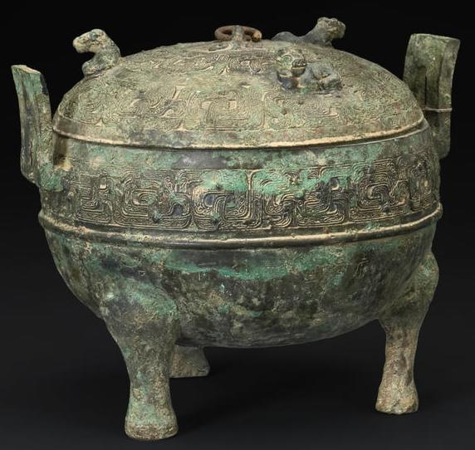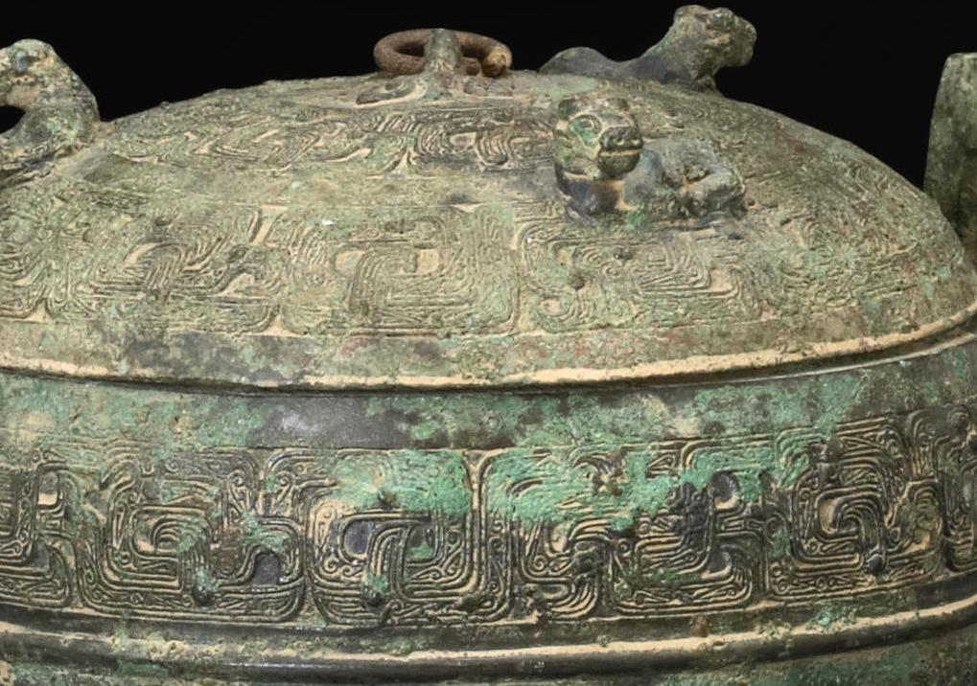

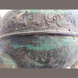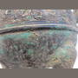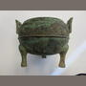

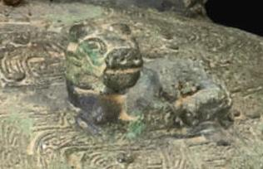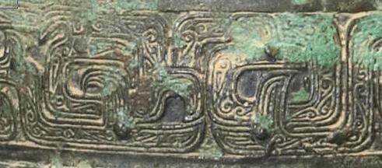

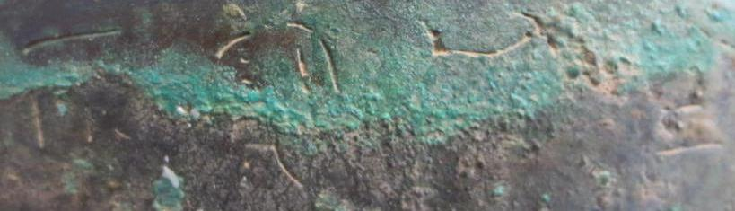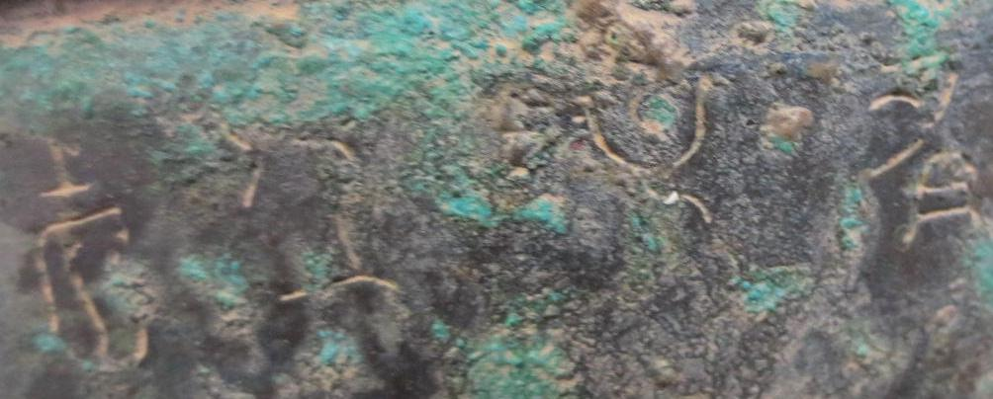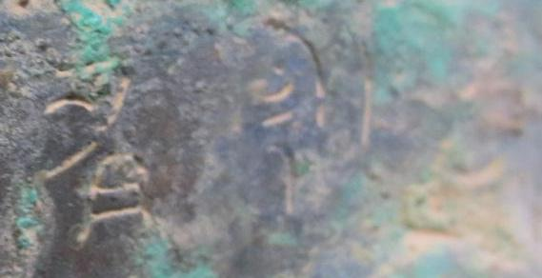

Click here to see more images.

12 Mar 2013 10:00 PDT [San Francisco](http://www.bonhams.com/locations/SF/)  
[Chinese Works of Art](http://www.bonhams.com/auctions/20901/61110/)  
[Back to auction 20901](http://www.bonhams.com/auctions/20901/?go_to_lot=5198)

Top of Form

* Go to lot number 

Bottom of Form

5198

[◄ Previous lot](http://www.bonhams.com/auctions/20901/lot/5197/) [Next lot ►](http://www.bonhams.com/auctions/20901/lot/5199/)

Property from Various Owners

A cast bronze covered ding

**Western Han**  
The compressed globular vessel with a band of scrolling taotie decoration on the body and two bands on the domed lid containing a central double-mask and ring handle surrounded by three raised finials of recumbent horses, the main body flanked by flared rectangular handles with a raised horizontal bead border in the middle with an incised inscription directly below the band, raised on three squat cabriole legs, the surface with raised mineral deposits and dirt throughout.   
*8in (20.3cm) width over handles  
6 1/2in (16.5cm) high*

Estimate:

US$ 40,000 - 60,000  
£25,000 - 38,000  
€30,000 - 45,000

### Footnotes

* Provenance:  
  small paper label of Dimitri Emmanuel Gran Collection attached  
    
  Compare to an example in the Avery Brundage Collection, illustrated by Rene-Yvon Lefebvre d'Argence in *Bronze Vessels of Ancient China in The Avery Brundage Collection* (Japan, 1977), p.119, no. B60 B29+.